*Covid 19 Tableau Project*

Gandham Niharika

Mail id : [niharikagandham23@gmail.com](mailto:niharikagandham23@gmail.com)

LinkedIn: [linkedin.com/in/niharika-gandham-150642257](https://www.linkedin.com/in/niharika-gandham-150642257)

GitHub : <https://github.com/niharikagandham>

Tableau link: https://public.tableau.com/views/covid19project_17285594519660/Story1?:language=en-US&:sid=&:redirect=auth&:display_count=n&:origin=viz_share_link

**INTRODUCTION**

**Project Description:**

This project focuses on analysing the global impact of the COVID-19 pandemic using a comprehensive dataset that tracks COVID-19 deaths, vaccinations, cases, and infection rates across various countries and regions. The data used in this project provides critical insights into the severity of the pandemic, highlighting how different areas of the world were affected over time.

I used SQL and Tableau for this project because they helped me handle the data effectively.

SQL made it

* easy to organize and query large datasets, allowing me to filter and analyze the vaccination and death data efficiently.

Tableau helped me

* turn that data into clear and interactive visuals, making it simple to spot trends and present the findings in an easy-to-understand way.

Together, they made the data analysis and presentation smoother and more insightful.

**Data Overview:**

This project uses two key datasets that track the global impact of COVID-19, focusing on vaccination efforts and COVID-19-related deaths across various countries and regions. The data spans multiple countries, covering several dimensions such as health, demographic, and economic indicators, which provide a comprehensive view of the pandemic's progression and responses.

**1. Vaccination Dataset:**

* **Scope:** This dataset tracks COVID-19 vaccinations across the world, documenting the distribution and uptake of vaccines in different countries and regions. It includes detailed country-level information such as:
  + iso_code, continent, location: Identifiers and geographic indicators to distinguish data for individual countries or regions.
  + date: The specific date for which the data was recorded.
  + new_tests, total_tests: Metrics related to COVID-19 testing in the respective country.
  + gdp_per_capita: A measure of the country's economic output per person, which can be used to analyze correlations between wealth and vaccination rates.
  + cardiovasc_death_rate, diabetes_prevalence: Indicators of pre-existing health conditions that could affect the population's vulnerability to COVID-19.
  + handwashing_facilities, hospital_beds_per_thousand: Measures of healthcare infrastructure, which are critical in understanding how countries managed the healthcare demands caused by the pandemic.
  + life_expectancy: A general health and longevity indicator that may influence a population's vulnerability to severe COVID-19 outcomes.

**2. Deaths Dataset:**

* **Scope:** This dataset focuses on the number of deaths attributed to COVID-19, tracking both new and cumulative deaths over time. It includes:
  + new_deaths, total_deaths: These columns capture the daily new deaths and the total death count to date for each location.
  + reproduction_rate: A measure of how quickly the virus is spreading in different regions, which can be used to understand the effectiveness of public health measures.
  + icu_patients, hosp_patients: Hospitalization data, including ICU admissions, which provides insight into the strain on healthcare systems.
  + weekly_icu_admissions, weekly_hosp_admissions: Trends in hospitalizations on a weekly basis, offering a view of how different waves of the pandemic affected hospital capacities.
  + new_deaths_smoothed_per_million: A metric that helps smooth out daily fluctuations, making it easier to observe longer-term trends in death rates.
  + Total Cases: The total number of confirmed COVID-19 cases in countries across all continents.
  + Total Deaths: Data on COVID-19 deaths by location, enabling the identification of regions that experienced higher mortality rates.

**SQL QUERIES FOR TABLEAU**

**STEP1:** Create a database and import the data (data was available in mygithub (https://github.com/niharikagandham)).

**Code:**

create database portfolioproject default character set 'utf8mb4';

use portfolioproject;

**STEP 2:** After executing each command, copy the results into separate Excel workbooks and save them individually.

**SQL QUERIES**

**1.** **GLOBAL NUMBERS**

**Code:**

Select SUM(new_cases) as total_cases, SUM(convert(new_deaths, signed)) as total_deaths, SUM(convert(new_deaths, signed))/SUM(New_Cases)*100 as DeathPercentage

From PortfolioProject.CovidDeaths

where continent is not null

order by 1,2

**RESULT:**



**2. PERCENT POPULATION INFECTED BY COUNTRY**

**CODE:**

Select Location, Population, MAX(total_cases) as HighestInfectionCount, Max((total_cases/population))*100 as PercentPopulationInfected

From PortfolioProject.CovidDeaths

Group by Location, Population

order by PercentPopulationInfected desc;

**RESULT:**

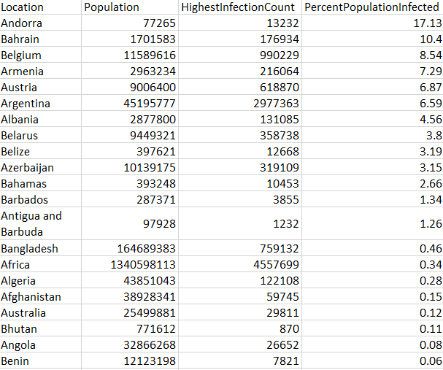

**3. PERCENT POPULATION INFECTED**

**CODE:**

Select Location, Population,date, MAX(total_cases) as HighestInfectionCount, Max((total_cases/population))*100 as PercentPopulationInfected

From PortfolioProject.CovidDeaths

Group by Location, Population, date

order by PercentPopulationInfected desc;

**RESULT:**

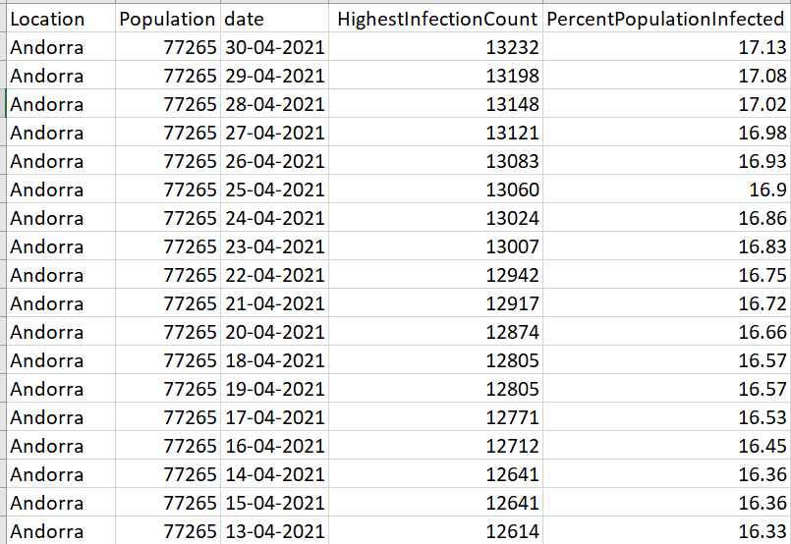

**4. Total Deaths by Location**

**CODE:**

select location, MAX(CONVERT(total_deaths, SIGNED)) as totaldeathcount

from portfolioproject.coviddeaths

where continent is not null

group by location

order by totaldeathcount desc;

**RESULT:**

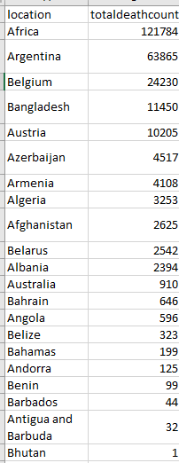

**5. Bangladesh COVID-19 Statistics: Cases and Deaths Overview**

**CODE:**

select location, date, total_cases, total_deaths, (total_deaths/total_cases)*100 as deathpercentage

from portfolioproject.coviddeaths

where location like 'bangladesh'

order by 1,2;

**RESULT:**

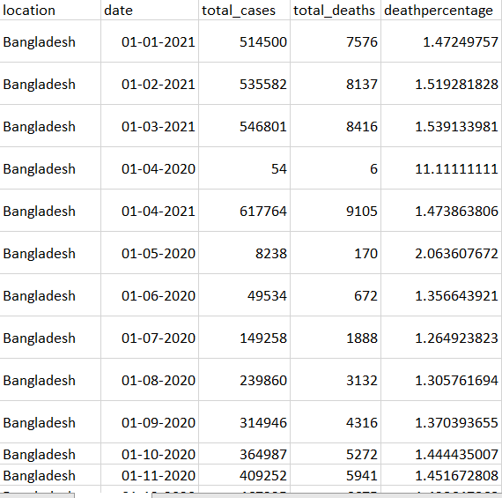

**6. COVID-19 Death Counts by Continent**

**CODE:**

select continent, MAX(CONVERT(total_deaths, SIGNED)) as totaldeathcount

from portfolioproject.coviddeaths

where continent is not null

group by continent

order by totaldeathcount desc;

**RESULT:**

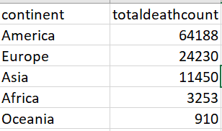

**STEP 3:** Now import all excel files to tableau.

**Visualization in tableau**

**1.** **GLOBAL NUMBERS**

To create a new sheet in Tableau for Query 1, select the relevant data source and drag Total Cases, Total Deaths, and Death Percentage to the Columns shelf. In the Show Me tab, choose Text Tables to display the data in table form. Use the Marks pane to add colours and labels for better visualization, and apply filters as needed to refine the data view. This will present the cases, deaths, and death percentage in an easy-to-read, customizable table format.

**Result:**

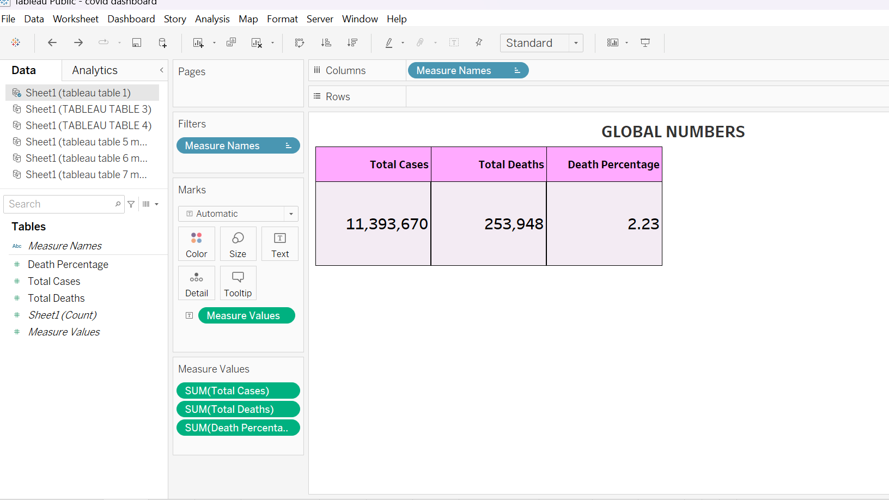

**2. PERCENT POPULATION INFECTED BY COUNTRY**

For the second sheet, to create a map, first ensure Tableau recognizes the Location column as a geographical field. If not Right-click on the Location field, select Geographical Role, and then choose Country/Region. Next, drag Longitude to the Columns shelf and Latitude to the Rows shelf. In the Marks pane, drag Percent Population Infected to Colour and Location to Label. This will generate a map that visually represents the percentage of the population infected across various locations.

**Result:**

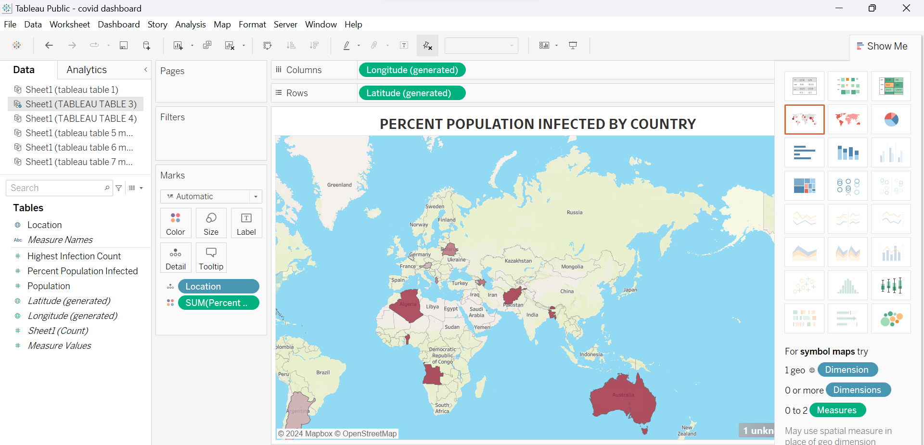

**3. PERCENT POPULATION INFECTED**

For the third sheet, start by dragging Date to the **Columns** shelf, then right-click on it and choose **Month**. Next, drag Percent Infection Rate to the **Rows** shelf, right-click on it, and select **Average**. Choose a **Line (Discrete)** chart for visualization or another style you prefer. In the **Marks** pane, drag Location to **Color** and **Label** to differentiate locations. If you want to filter specific locations, drag Location to the **Filters** pane to select the ones you're interested in.

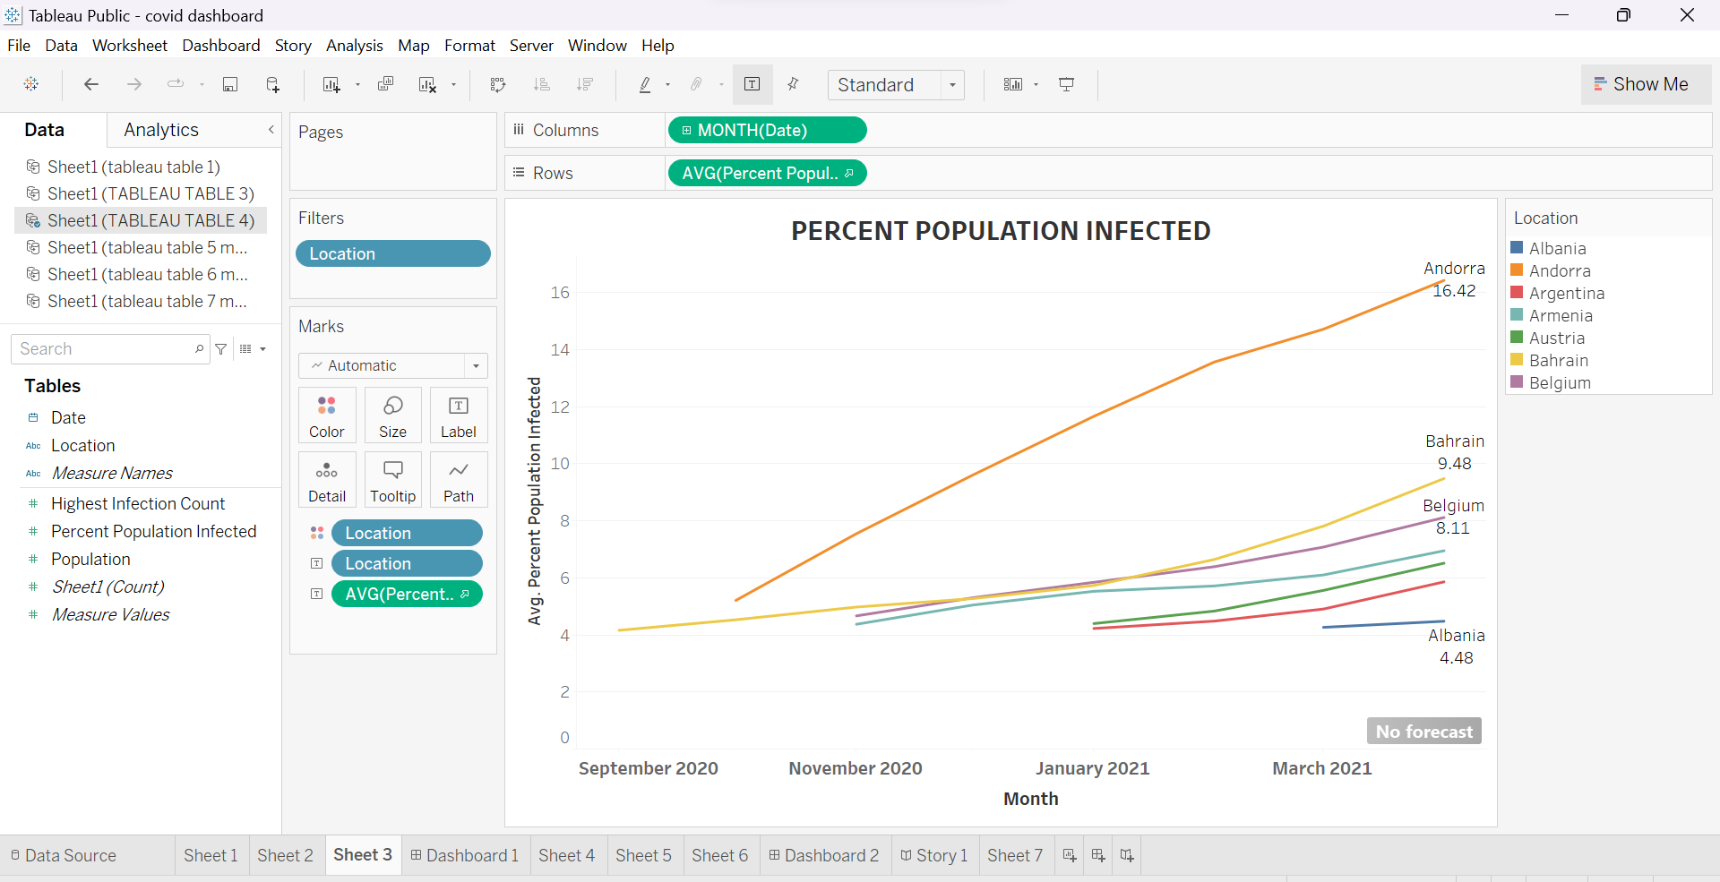

**4. Total Deaths by Location**

A map chart where total death by location is represented by colours and Location is displayed as labels. Geographical roles were assigned to the location field for accurate mapping.

**Result**:

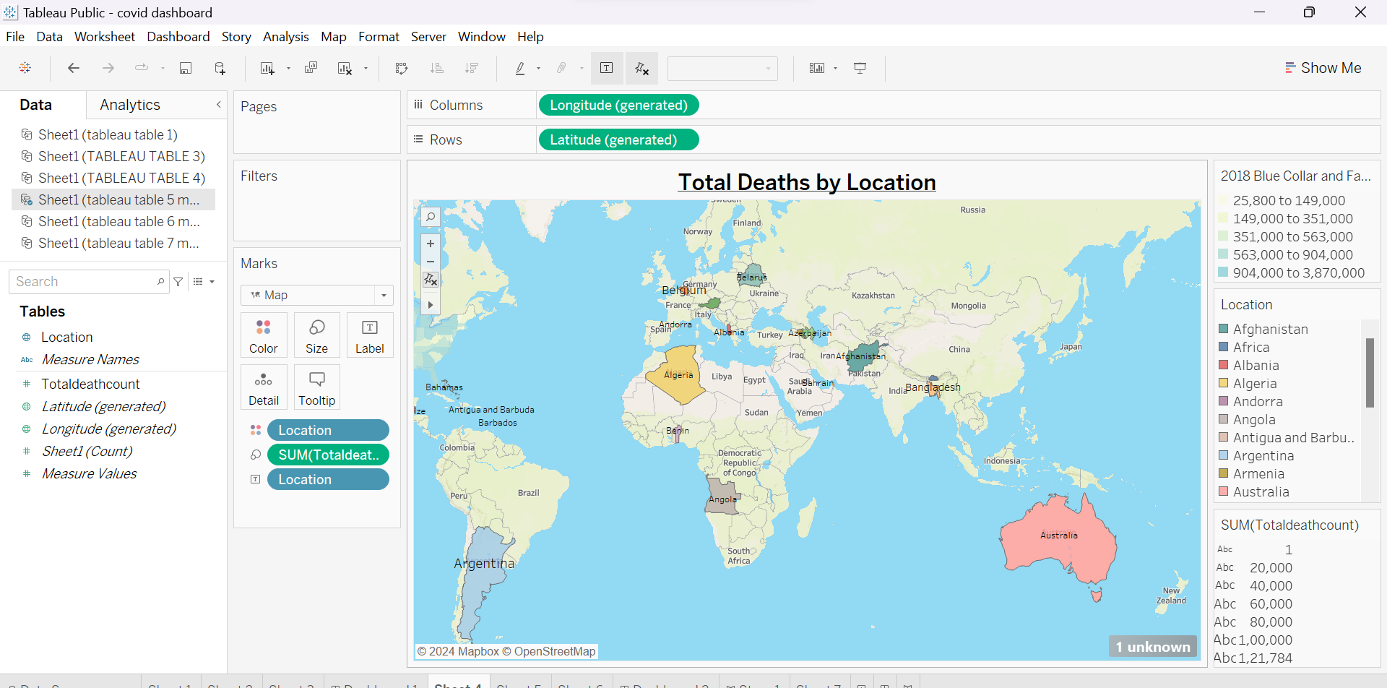

**5. Bangladesh COVID-19 Statistics: Cases and Deaths Overview**

To create a bar chart visualizing COVID-19 statistics for Bangladesh, start by dragging Location and Date to the Columns shelf. Next, add Total Cases to the Rows shelf. Drag Date to the Colour shelf to differentiate the bars by Month. To focus on the most significant data, filter the Death Percentage to show the maximum value. Finally, select the Bar Chart option for visualization. This will effectively display the overview of cases and deaths in Bangladesh.

**Result:**

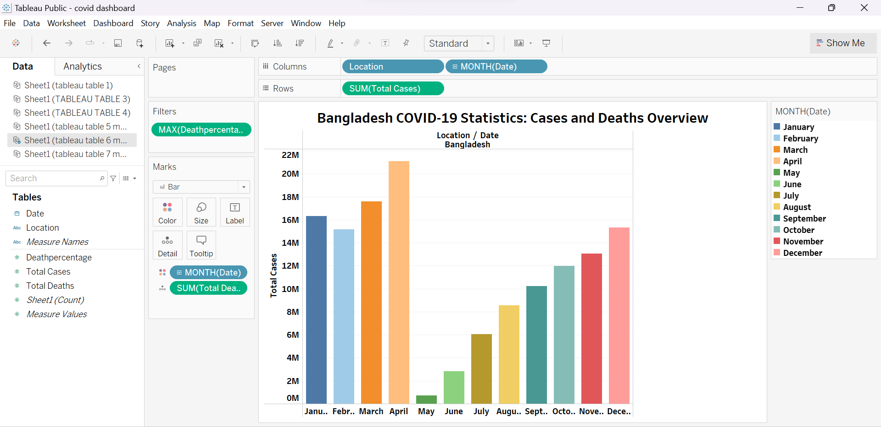

**6. COVID-19 Death Counts by Continent**

For Sheet 6, start by dragging Continent to the Columns shelf and Total Death Count to the Rows shelf. Then, drag Total Death Count again to the Colour and Label sections in the Marks pane. This will create a visualization that shows the total death count by continent, with colours representing the magnitude of deaths and labels providing numerical values for clarity.

**Result:**

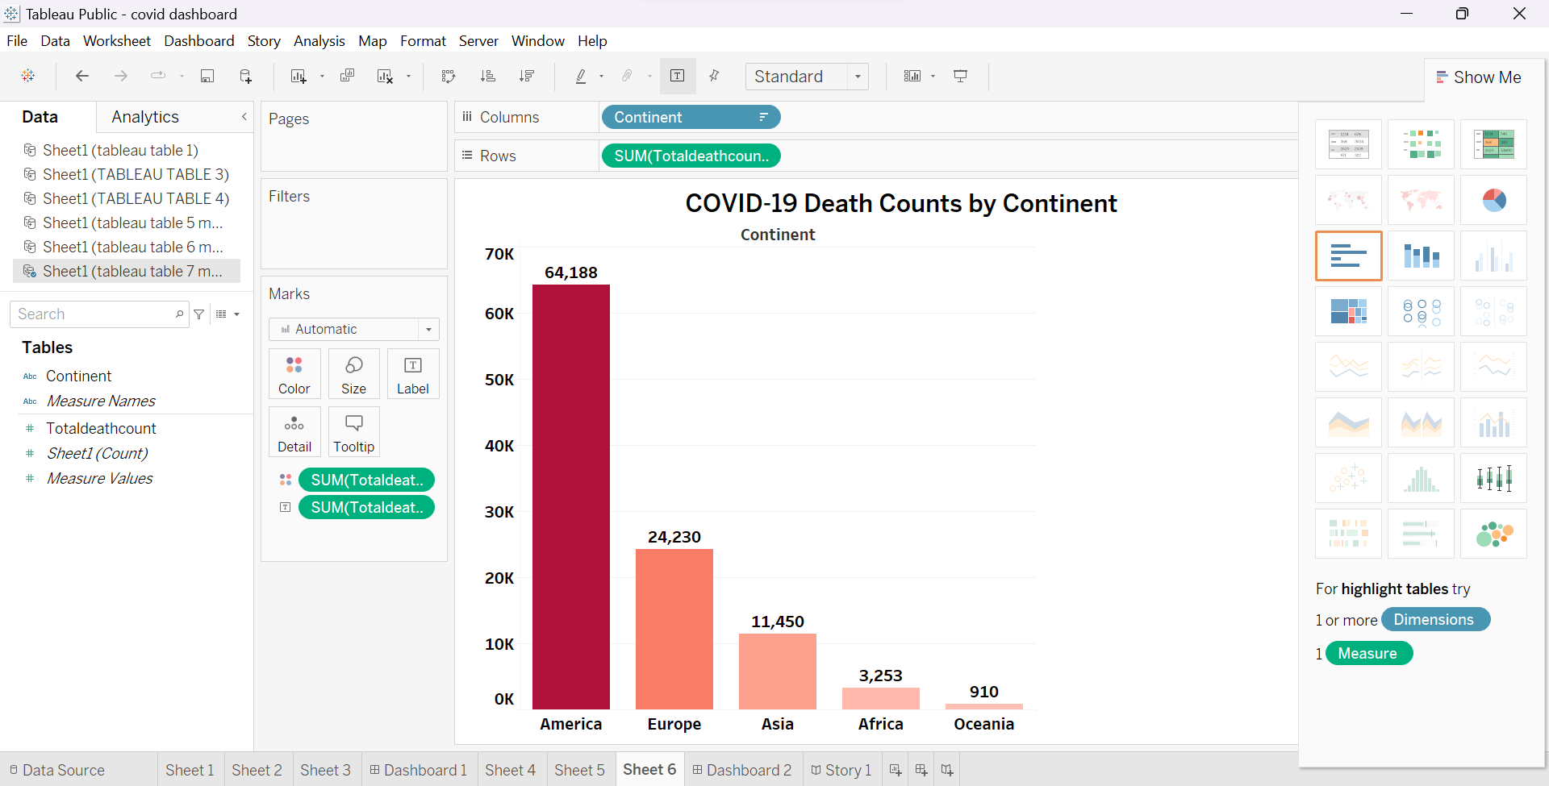

**Creating dashboards:**

**1. Open the Dashboard Tab**

- In Tableau, go to the Dashboard tab at the bottom and click on "New Dashboard."

**2. Set Dashboard Size**

- On the left-hand side under Size, select the appropriate size for your dashboard (e.g., "Automatic" for dynamic resizing or a custom size if needed).

**3. Add Worksheets to the Dashboard**

- On the left panel under Sheets, you'll see the list of all your worksheets.

- Drag and drop each worksheet into the dashboard layout:

**For dashboard 1:**

- Drag the Global Numbers sheet to the top.

- Drag the Map (Percent Population Infected by Country) to one side (e.g., the right side).

- Drag the Line Chart (Percent Population Infected Over Time) below the Global Numbers section.

**For dashboard 2:**

-Drag the Map (Total Deaths by Location) to the left side of the dashboard.

-Drag the Bar Chart (Bangladesh COVID-19 Statistics: Cases and Deaths) to the upper-right section of the dashboard.

-Drag the Bar Chart (COVID-19 Death Counts by Continent) to the bottom-right section.

**4. Adjust Layout and Positioning**

- Once the sheets are on the dashboard, you can adjust their position:

- Resize them by dragging the edges.

- Move the objects by dragging them to different areas of the dashboard.

**5. Customize Objects (Optional)**

- Add text boxes, images, or additional elements if necessary:

- To add text, click "Text" under Objects in the left pane and drag it to the desired location.

- You can also add filters, legends, or parameters by dragging them from the left panel.

**6. Format the Dashboard**

- Adjust the font, background color, or borders of each object for a cleaner appearance.

- Format any titles or captions by clicking on the object, right-clicking the title, and selecting "Edit Title."

**7. Preview and Fine-Tune**

- Use Device Preview (on the left side) to see how the dashboard will look on different devices like phones or tablets.

- Fine-tune spacing, alignments, and other adjustments.

**8. Save and Publish**

- Once you are satisfied, save the dashboard.

- Publish it to Tableau Public, Tableau Server, or export it to a PDF as needed.

**Result:**

**Dashboard 1:**

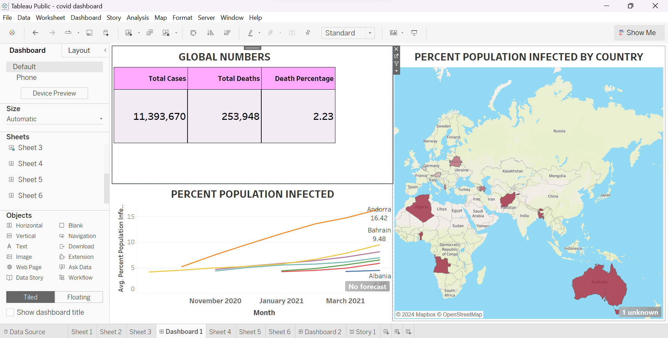

**Dashboard 2:**

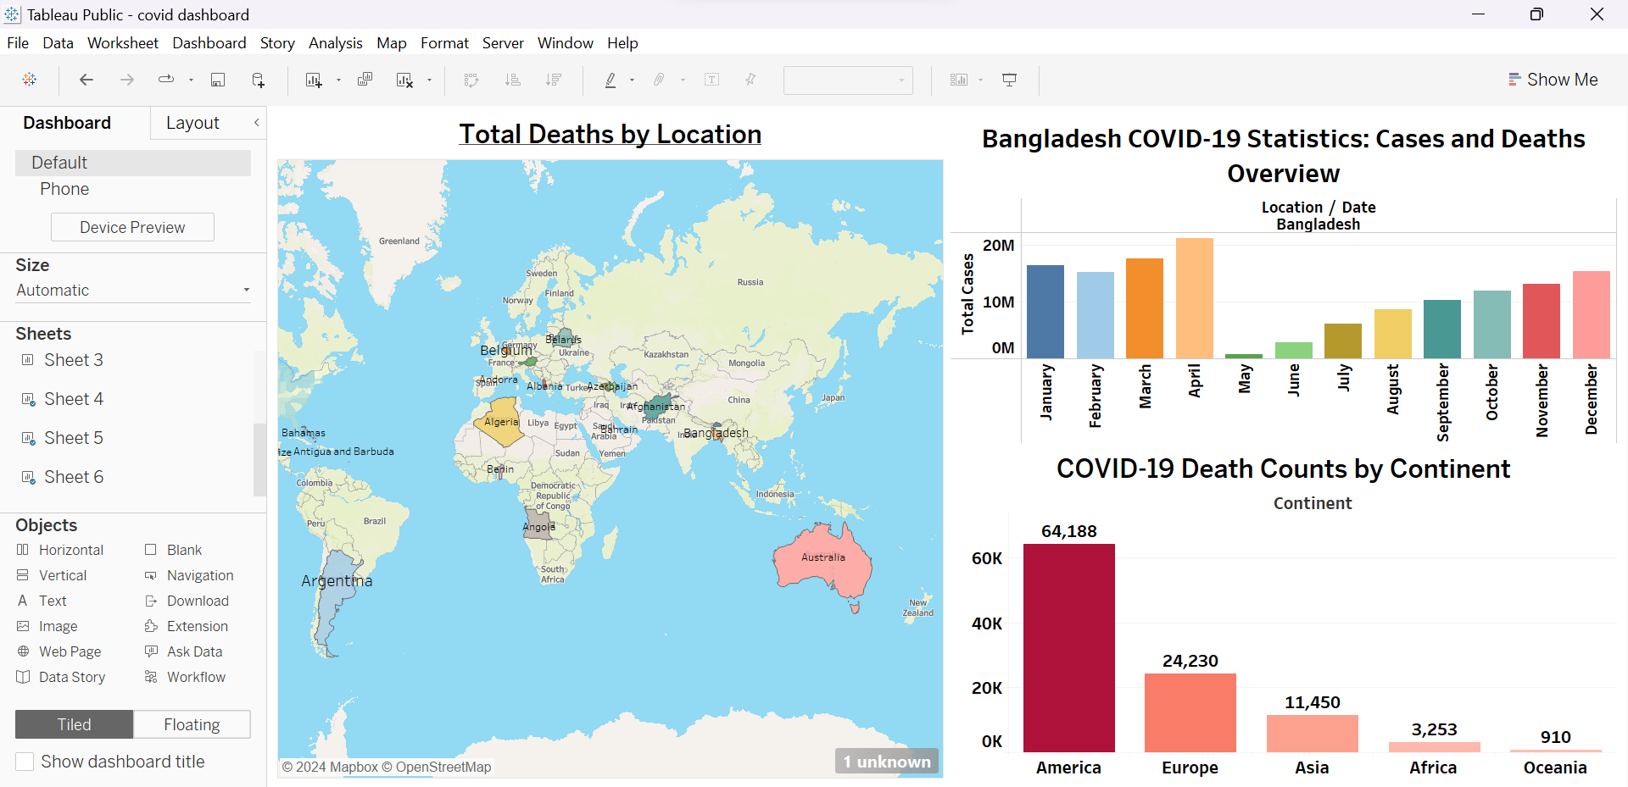



**Mail id :** niharikagandham23@gmail.com

**LinkedIn :** linkedin.com/in/niharika-gandham-150642257

**GitHub :** [**https://github.com/niharikagandham**](https://github.com/niharikagandham)

**Tableau link:** https://public.tableau.com/views/covid19project_17285594519660/Story1?:language=en-US&:sid=&:redirect=auth&:display_count=n&:origin=viz_share_link